**Ascendion Timesheet Confirmation**

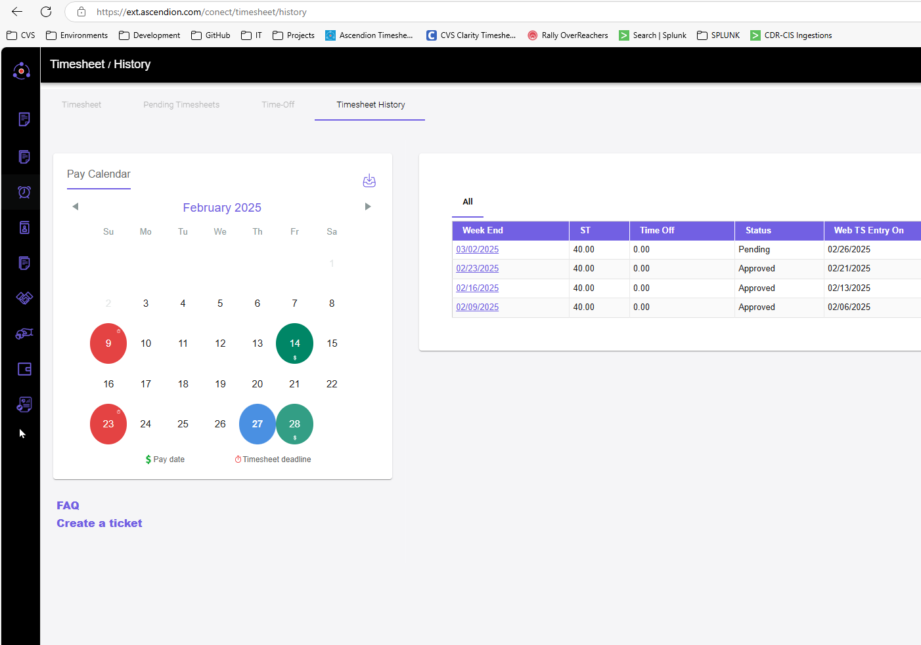**Preston Brown**